**Lab Task: "Perform a Hotfix”**

I have completed tasks in two sets. In the first set, I set up Git. In the second set, I followed the lab task instructions step by step.

Set-A: git setup

Step 1: Project Path Setup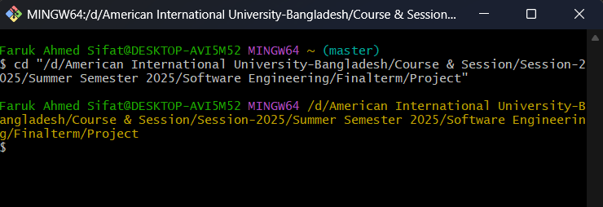

Step 3: Git Identity Set & Verify

Step-4: Create REDME.md file in local system

Step-5: Add Files & Commit Initial

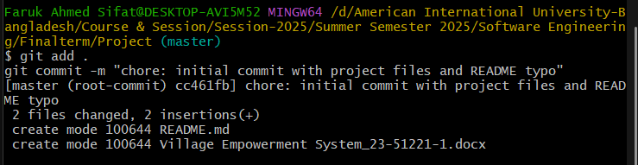

Step-6: Create GitHub Repository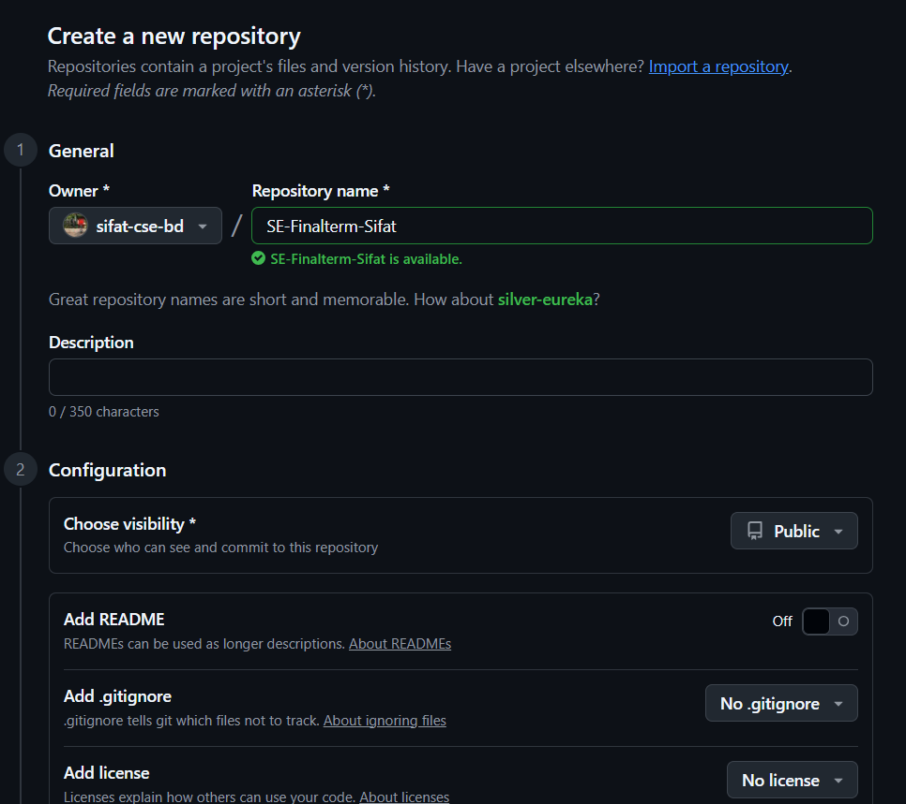

Step 6: Link Local Repo to GitHub

**Set-B: Hotfix Workflow (Lab Task)**

Step-1: Discover the Issue: Switch to Main & Pull

Step-2: Create Hotfix Branch

Step-3: Fix Typo in README.md (implimentation → implementation):

Step-4: Commit the Fix

Step-5: Push Hotfix

Step 6: Create Pull Request

|  |  |
| --- | --- |
| Before renaming the title & description: | After renaming the title & description: |
|  |  |

Finally finished:

